LAB SUBMISSION

Nabiha Khan

**JOINS**

* Inner Join

SELECT Pat.PID, Test.Reports

FROM Pat

INNER JOIN Test ON Pat.PID = Test.PatID;

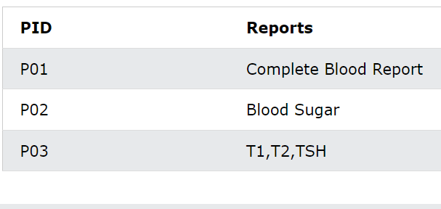

* Left Outer Join

SELECT Pat.PID, Test.Reports

FROM Pat

LEFT JOIN Test ON Pat.PID = Test.PatID

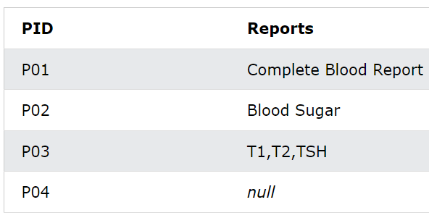

* Right Outer Join

SELECT Pat.PID, Test.Reports

FROM Pat

RIGHT JOIN Test ON Pat.PID = Test.PatID

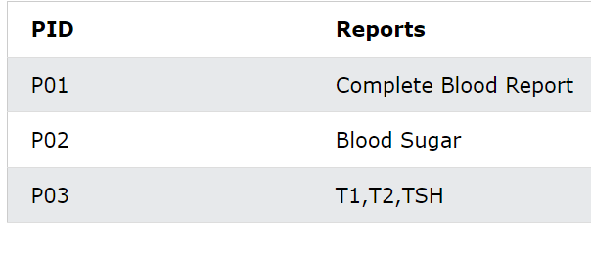

* Full Outer Join

SELECT Pat.PID, Test.Reports

FROM Pat

FULL OUTER JOIN Test ON Pat.PID = Test.PatID

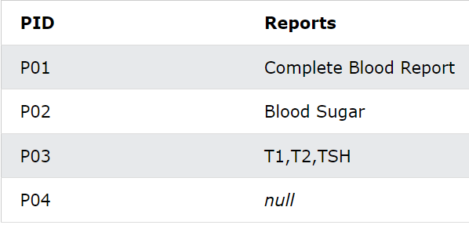

* Cross Join

SELECT Pat.PID, Pat.DoA,Doc.docname, Doc.spec

FROM Pat

CROSS JOIN Doc

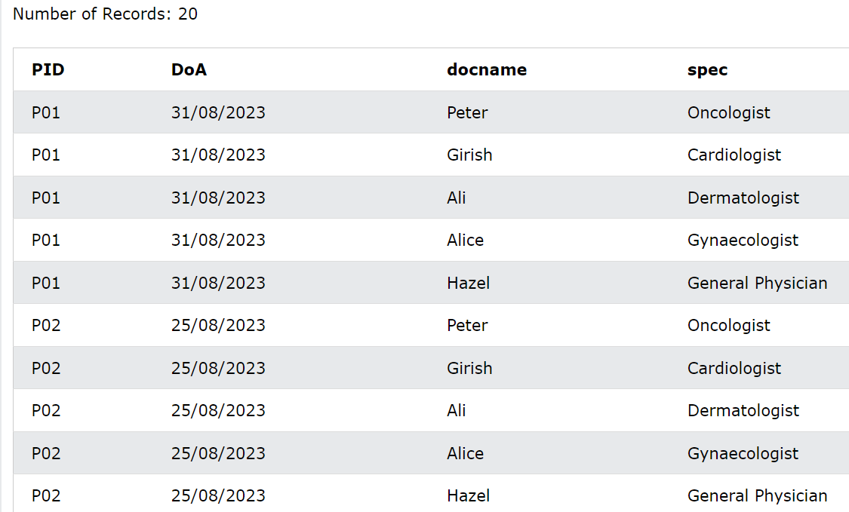

* Self Join

SELECT Doc1.docname AS Doctor, Doc2.spec AS Specialization

FROM Doc AS Doc1 JOIN Doc As Doc2 ON Doc1.docid=Doc2.docid;

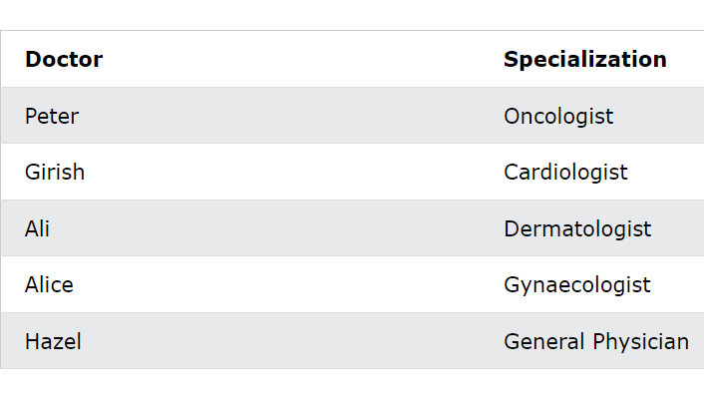

**SUBQUERIES**

* Scalar Subquery

Select PName, PID, Treatment_Type

from Pat

WHERE

PID=(SELECT PID from Pat where PID='P03');

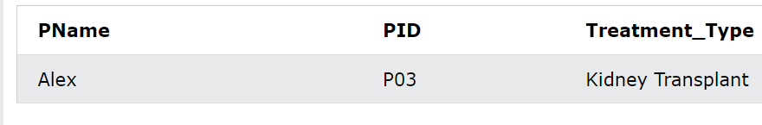

* Multi-valued Subquery

Select PName

from Pat

WHERE PID IN (SELECT PID from Pat

where PID='P03' AND DoA='19/08/2023');

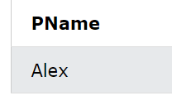

* Correlated Subquery

Select PName,PID

from Pat AS p1

WHERE PID =

(SELECT MAX(PID)

FROM Pat AS p2

WHERE p2.PID=p1.PID)

ORDER BY DoA;

